**IST 4030 – DATABASE MANAGEMENT SYSTEMS**

**Class Project**

Relationship

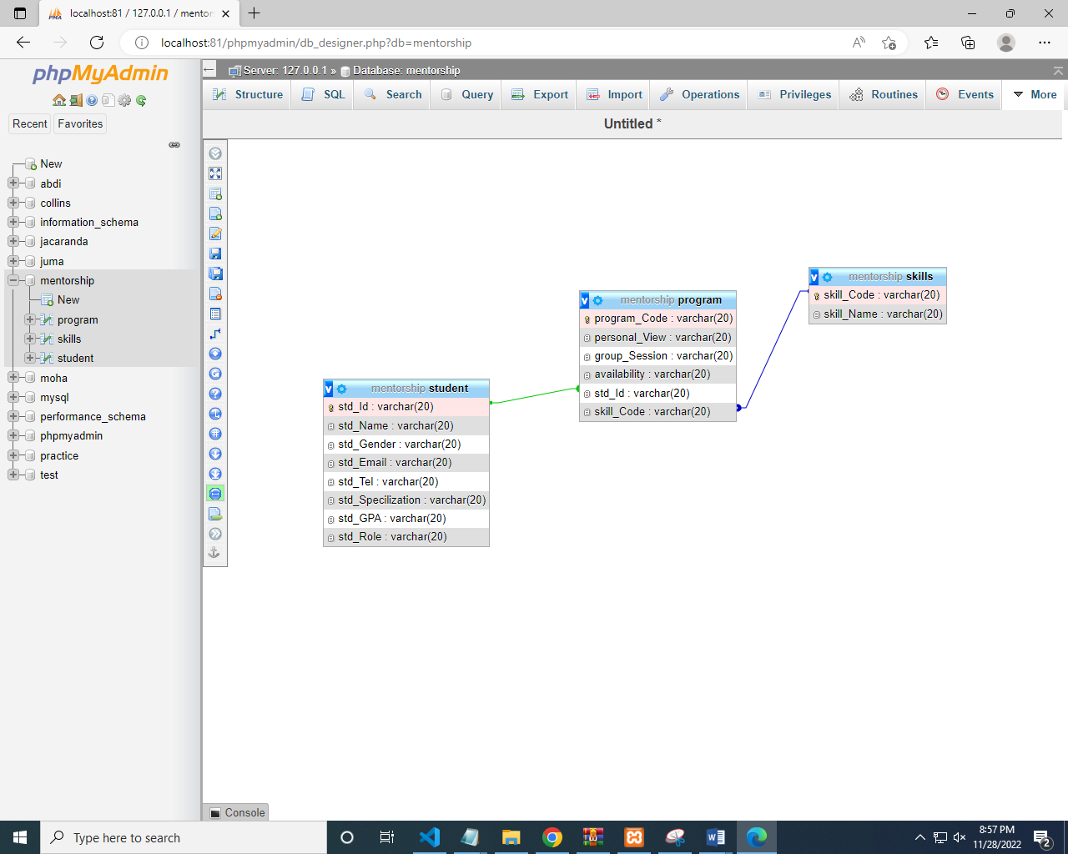

Student table

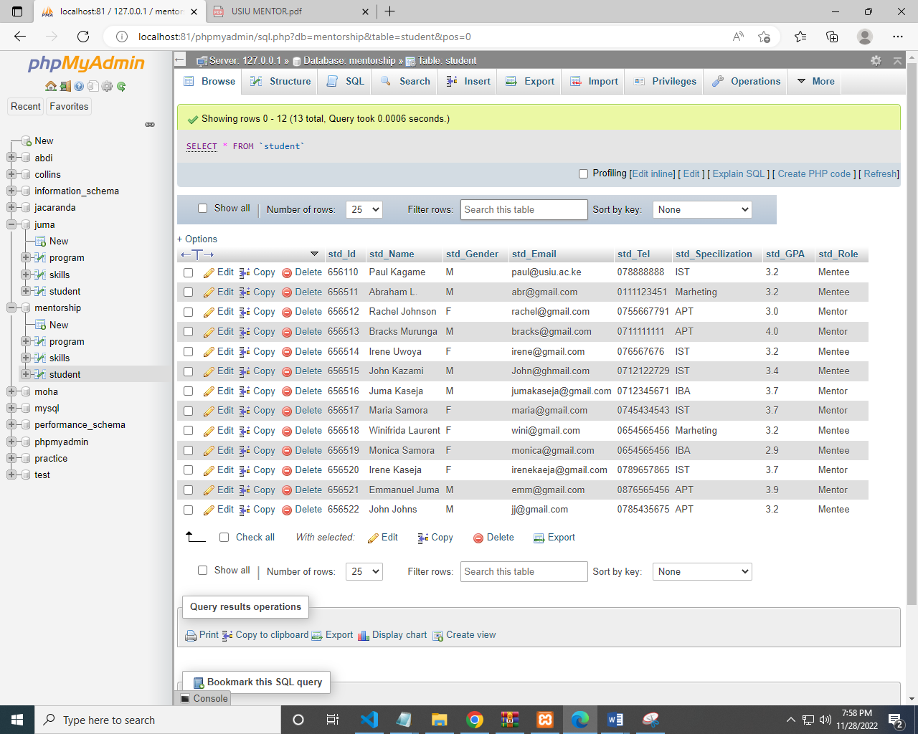

Skills table

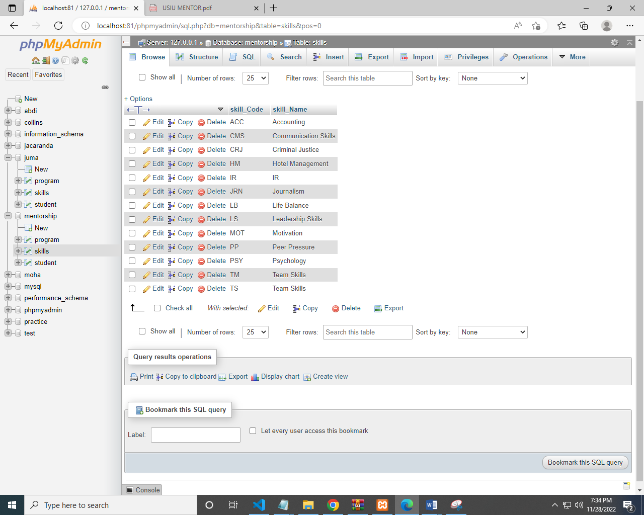

Program table

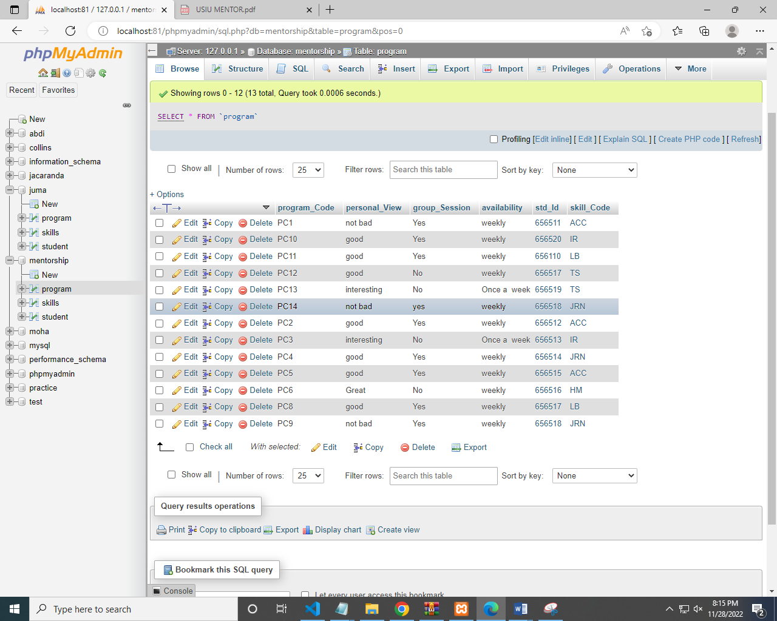

Question:

* A query that can be used to display the details of a student and their mentors

Select * from student;

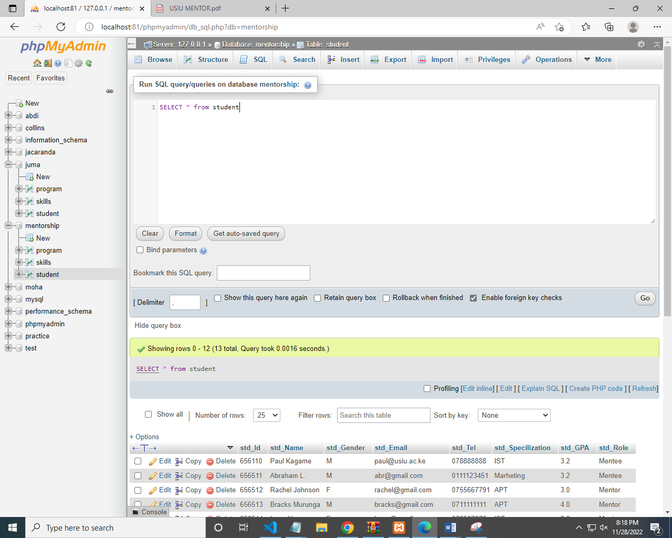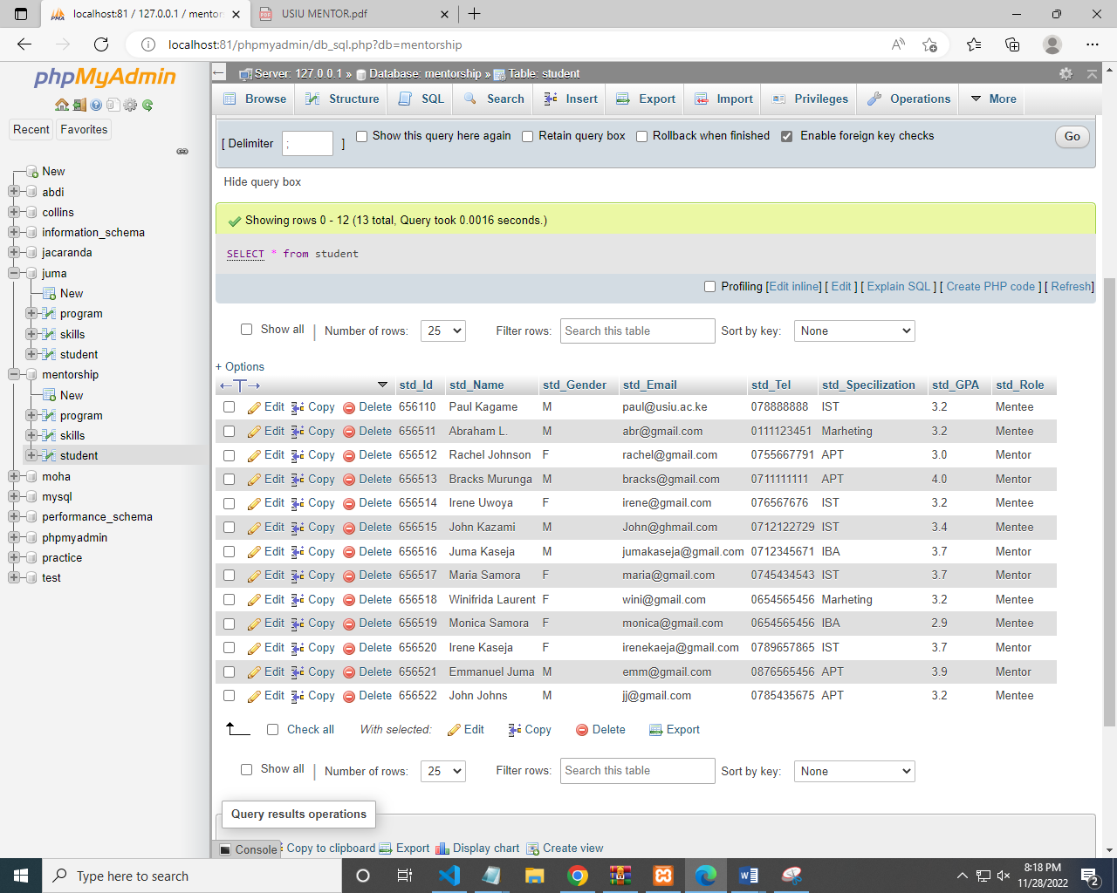

Question:

* A transaction that can be used to assign a student a selected mentor. Only a student with a good GPA can be added as a mentor.

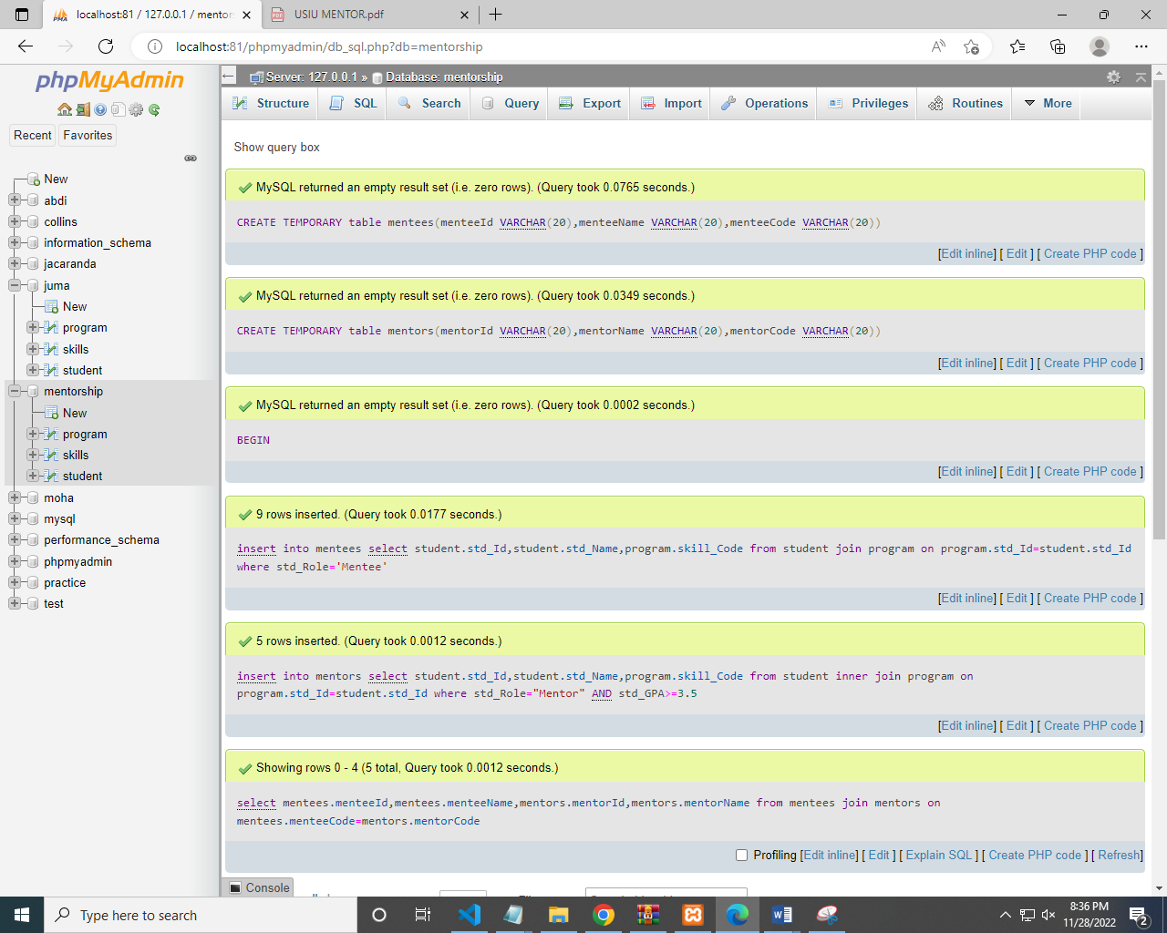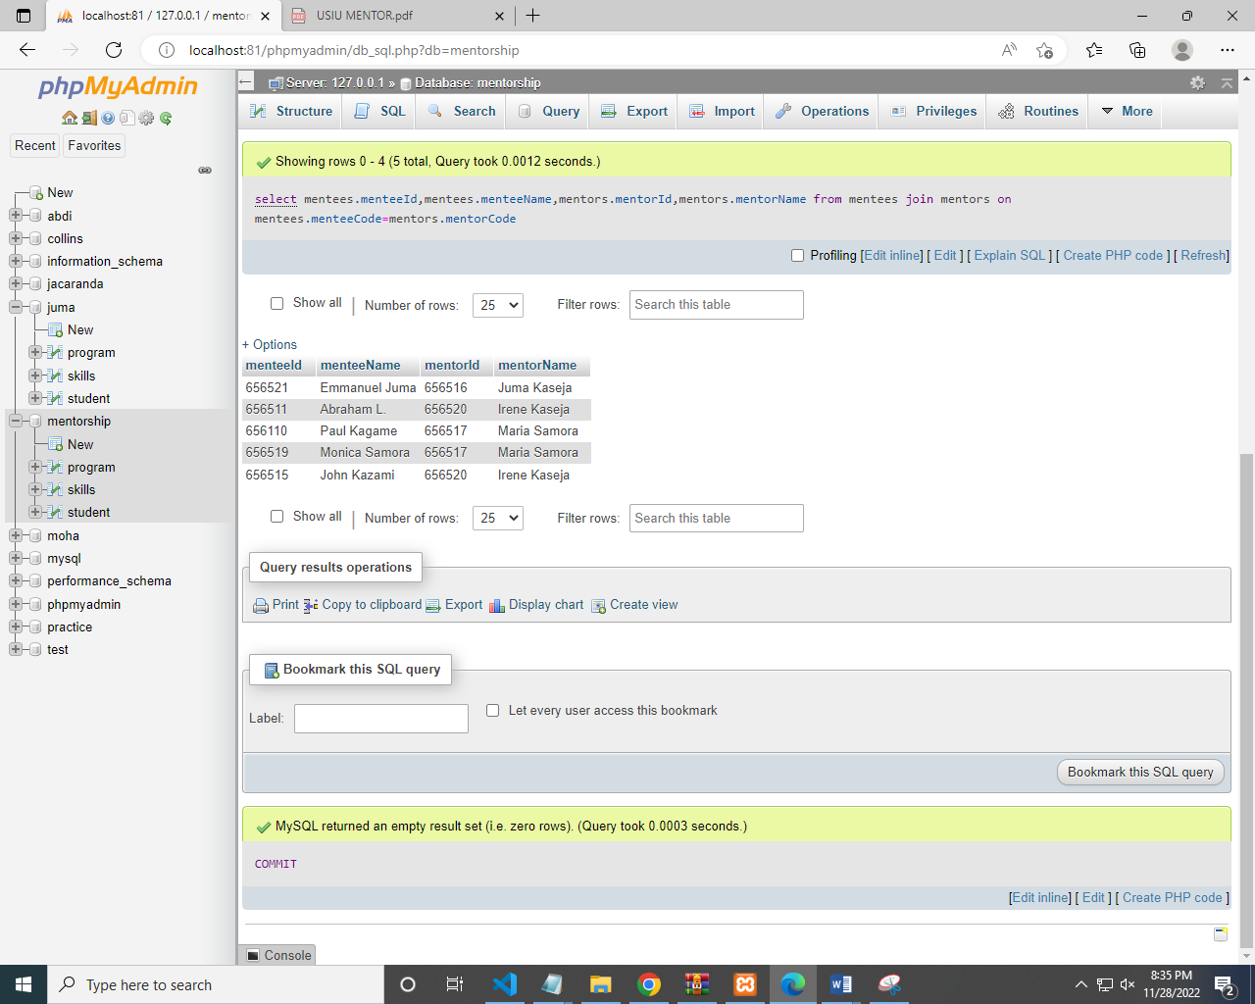

Code:

CREATE TEMPORARY table mentees(menteeId VARCHAR(20),menteeName VARCHAR(20),menteeCode VARCHAR(20));

CREATE TEMPORARY table mentors(mentorId VARCHAR(20),mentorName VARCHAR(20),mentorCode VARCHAR(20));

BEGIN;

insert into mentees select student.std_Id,student.std_Name,program.skill_Code from student join program on program.std_Id=student.std_Id

where std_Role='Mentee';

insert into mentors select student.std_Id,student.std_Name,program.skill_Code from student inner join program on program.std_Id=student.std_Id

where std_Role="Mentor" AND std_GPA>=3.5;

select mentees.menteeId,mentees.menteeName,mentors.mentorId,mentors.mentorName from mentees join mentors

on mentees.menteeCode=mentors.mentorCode ;

COMMIT;

Question:

* A report showing the students that an Alumnus is currently mentoring.

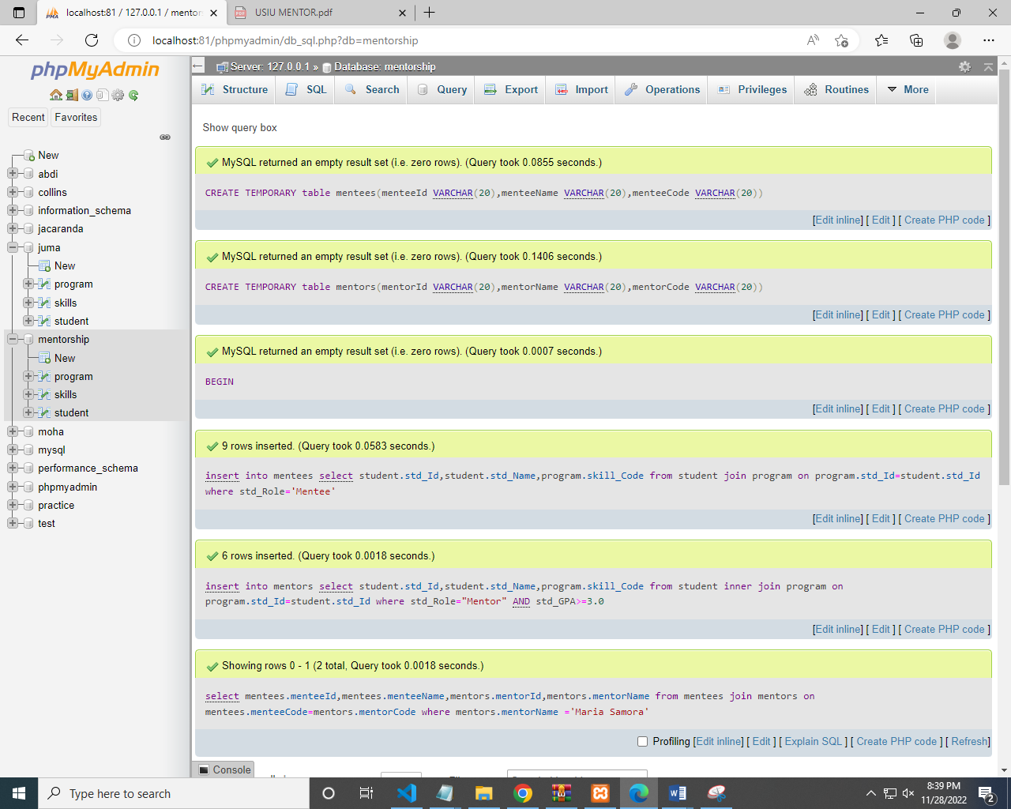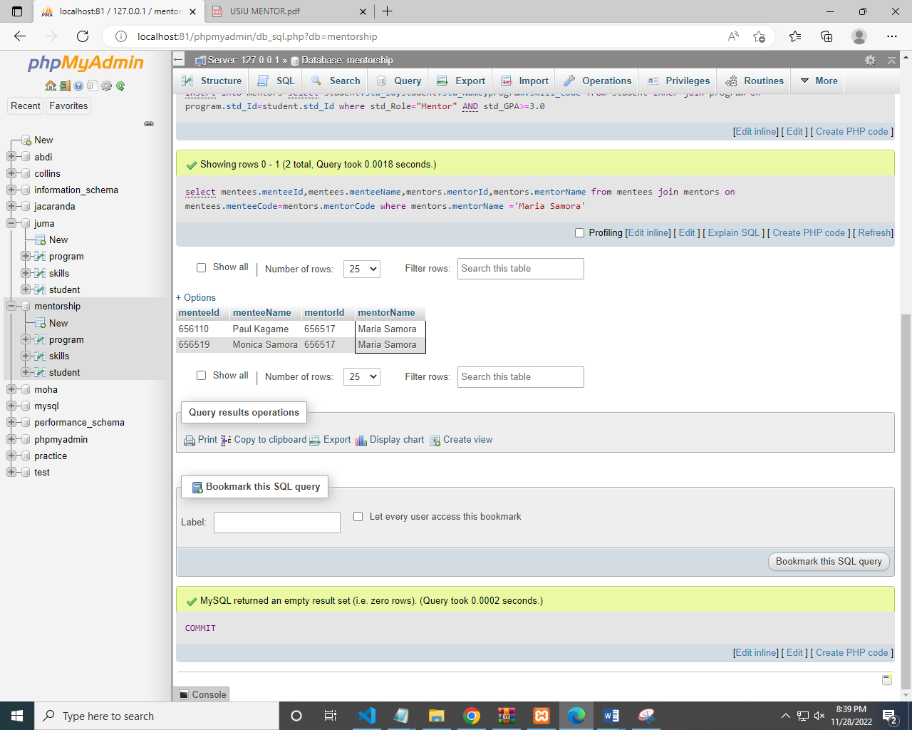

Code:

CREATE TEMPORARY table mentees(menteeId VARCHAR(20),menteeName VARCHAR(20),menteeCode VARCHAR(20));

CREATE TEMPORARY table mentors(mentorId VARCHAR(20),mentorName VARCHAR(20),mentorCode VARCHAR(20));

BEGIN;

insert into mentees select student.std_Id,student.std_Name,program.skill_Code from student join program on program.std_Id=student.std_Id

where std_Role='Mentee';

insert into mentors select student.std_Id,student.std_Name,program.skill_Code from student inner join program on program.std_Id=student.std_Id

where std_Role="Mentor" AND std_GPA>=3.0;

select mentees.menteeId,mentees.menteeName,mentors.mentorId,mentors.mentorName from mentees join mentors

on mentees.menteeCode=mentors.mentorCode where mentors.mentorName ='Maria Samora';

COMMIT;

Question:

* A report showing the students that require mentorship in Journalism Skills.

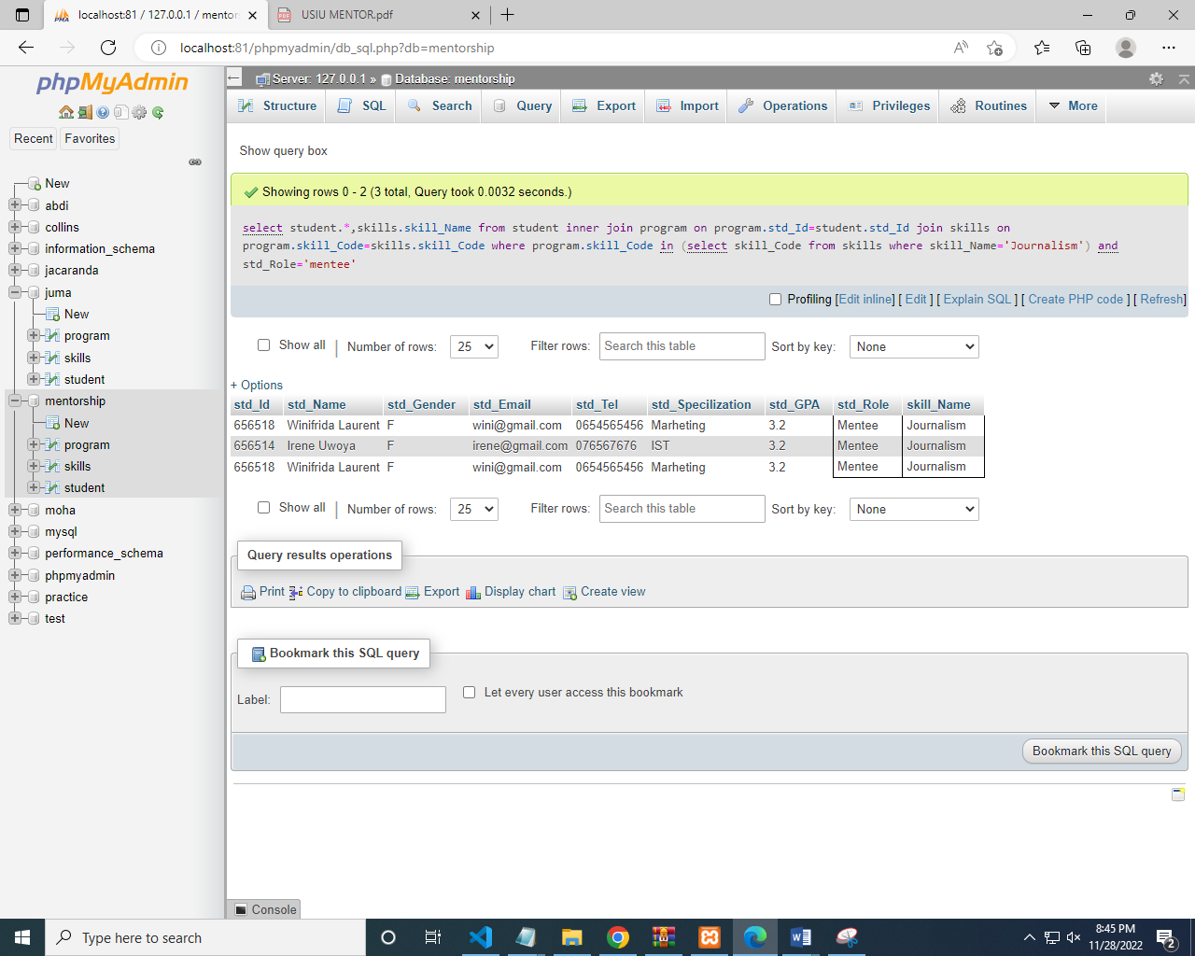

Code:

select student.*,skills.skill_Name from student inner join program on program.std_Id=student.std_Id

join skills on program.skill_Code=skills.skill_Code

where program.skill_Code in (select skill_Code from skills where skill_Name='Journalism') and std_Role='mentee';